





**Pre-Application Meeting**

**Quick Guide Instructions for**

**Iowa EASY Air**

Iowa Department of Natural Resources

Wallace State Office Building

Air Quality Bureau

502 E 9th St

Des Moines, IA 50319

Phone: (515) 725-8200

**Contact the Iowa EASY Air Helpdesk**

**Email:** [**easyair@dnr.iowa.gov**](mailto:easyair@dnr.iowa.gov)

**Or call (515) 725-9569 or (515) 204-3749**

# Table of Contents

Table of Contents 2

List of Figures 2

1. Adding the Pre-Application Meeting Application to Your Account 3

2. Finding the Pre-Application Meeting Application 6

3. Filling Out and Submitting a Pre-Application Meeting Application 7

3.1 Pre-Application Options 8

3.2 Form CP 8

3.3 Form AF 10

3.4 Attachments 10

3.5 Validation 12

3.6 Submission 13

# List of Figures

Figure 1 Dashboard Buttons to Create a New Submittal 3

Figure 2 Submittal Menu 3

Figure 3 Link to Submittal Types Associated with my Account 4

Figure 4 Available Submittal Types 4

Figure 5 My Account Menu 5

Figure 6 Basic Information Tabs 5

Figure 7 Associate Facility Button 5

Figure 8 Associate Facility Search 6

Figure 9 Facility Search Results and Adding Submission Type 6

Figure 10 Dashboard Buttons to Create a New Submittal 7

Figure 11 Submittal Menu 7

Figure 12 Construction Pre-Application Icon 7

Figure 13 Pre-Application Options Example 8

Figure 14 Department Review Example 8

Figure 15 Form CP Screen 8

Figure 16 Form CP Screen 9

Figure 17 Form AF Screen 10

Figure 18 Attachment Screen 11

Figure 19 Attachment Screen 11

Figure 20 Example Attachment Screen 12

Figure 21 Example Validation Screen 13

Figure 22 Example Certificate of Submission Screen 13

Figure 23 Confirmation of Submittal 14

This document provides directions on how to apply for a Pre-Application Meeting in the Iowa EASY Air System.

(Note: This document is written to explain how a Responsible Official can submit an application for a Pre-Application Meeting. As with other submittal types within the Iowa EASY Air system, the Responsible Official may delegate the completion of these forms to a Preparer. The Preparer can complete the forms and have the Responsible Official complete the certification and submit the application. The instructions for assigning a Preparer for a facility and submittal type are covered in other parts of the Iowa EASY Air documentation.)

# Adding the Pre-Application Meeting Application to Your Account

Before you are able to apply for a Pre-Application Meeting in the Iowa EASY Air system, you will need to add the Pre-Application Meeting application to your account.

**Viewing Associated Application Types**

If you do not know what application types are associated to your account, you may navigate to the Air Department Submittal Type List page and view the submittal types associated with your account. There are two ways to the Air Department Submittal Type List page within the Iowa EASY Air system.

For one method, on your dashboard click on the “Apply for a New Submittal” button in the upper left-hand corner of the dashboard as shown in Figure 1.

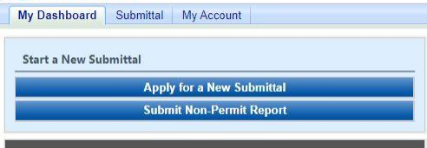

Figure 1 Dashboard Buttons to Create a New Submittal

Alternatively, hover over the Submittal dropdown menu and select “Start a New Submittal” as shown in Figure 2.

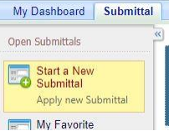

Figure 2 Submittal Menu

Next, you will see the application icons for the different types of submittals available to you in the system as shown in Figure 3.

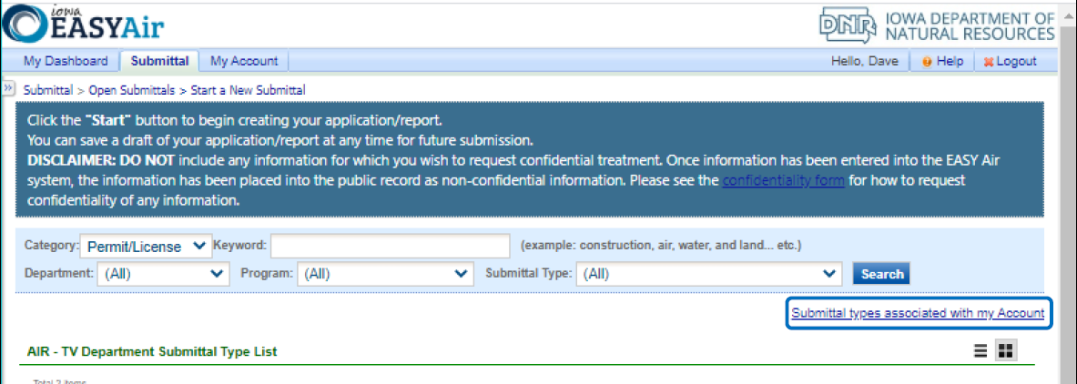

Figure 3 Link to Submittal Types Associated with my Account

Next, click on the link labeled “Submittal types associated with my Account” on the right side of the screen and the “Available Submittal Types” screen will appear as shown in Figure 4. On this screen, you are able to view the available submittal types and the submittal types already associated with your account.

A screenshot of the "Available Submittal Types". Two sections are shown, the "Available Submittal Types" and "Submittal Type Association Instruction".

Figure 4 Available Submittal Types

If you don’t see the Pre-Application Meeting application associated with your account, click on “Add More”. This will take you to the “Basic Information” page. Follow the instructions below to associate the application type.

**Associate an Application Type**

To associate an application type to your account, you will need to navigate to the “Associate Facilities” tab. To navigate to the “Associate Facilities” tab, on your dashboard hover on “My Account” and click on “Basic Information” as shown in Figure 5.

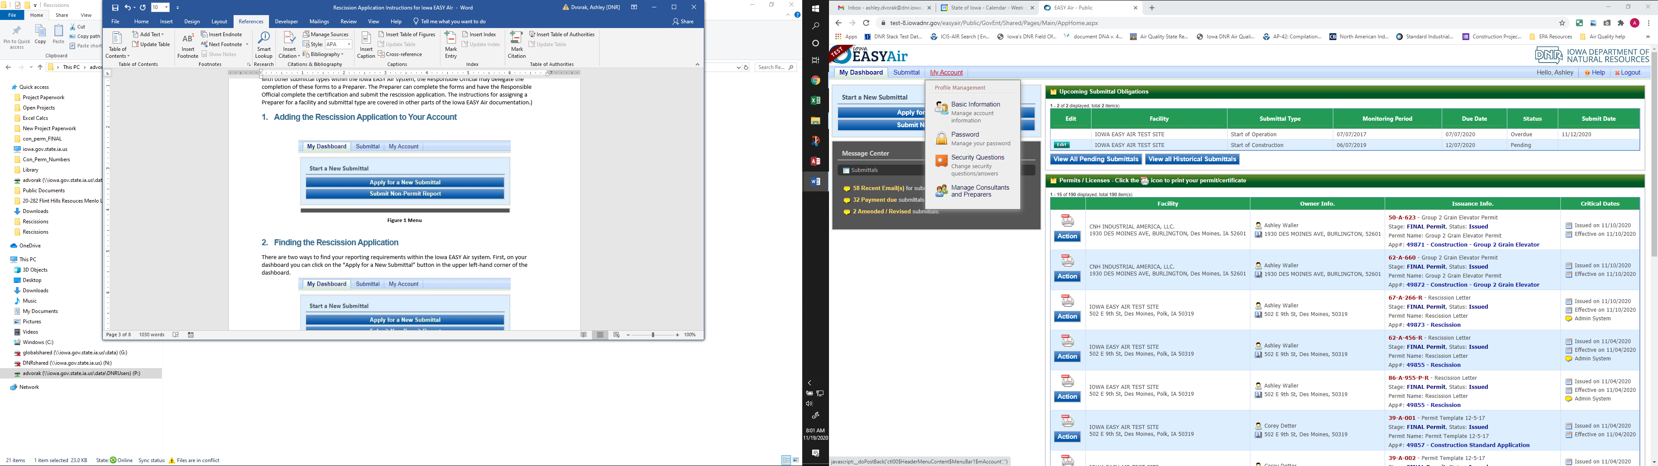

Figure 5 My Account Menu

The Basic Information page will appear. As shown in Figure 6, this page will have four tabs on top. Click on the “Associate Facilities” tab. This tab will show all your associated facilities and application types you currently have on your account.

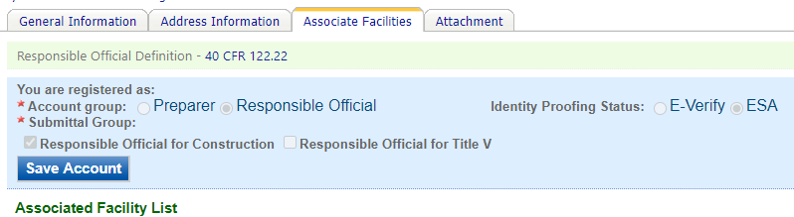

Figure 6 Basic Information Tabs

Next, scroll to the bottom of the page and you should see three buttons, as shown in Figure 7 below. Please click on “Associate Facility”.

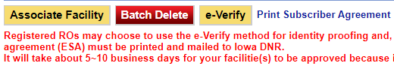

Figure 7 Associate Facility Button

The facility search will appear as shown in Figure 8 below. Enter in your facility information and click, “Search”. You may search by Facility Name, Address, or Facility Number.

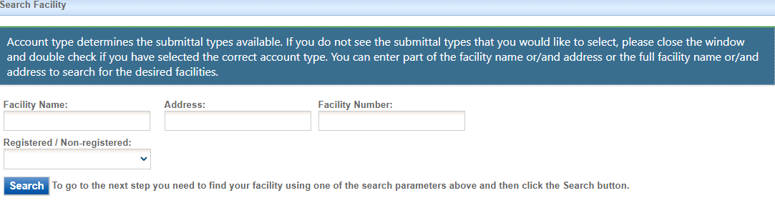

Figure 8 Associate Facility Search

The facility information will appear below the facility search as shown in Figure 9. Select the check box for the facility and the “Construction Pre-Application” check box under submission type.

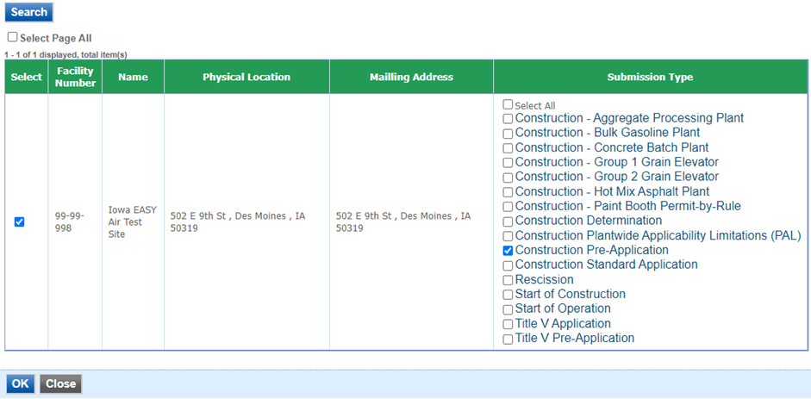

Figure 9 Facility Search Results and Adding Submission Type

Next, click “Ok” and then click “Close”. This will associate the Pre-Application Meeting application to your account. If you went through the e-Verify subscriber agreement process when you set up your account, you will be able to use the Pre-Application Meeting application after this step. However, if you sent in the paper subscriber agreement form, you will have to wait until the Iowa EASY Air Administrator completes the association of the Pre-Application Meeting application to your account. You will receive an email from the Iowa EASY Air Administrator when the association of the Pre-Application Meeting application has been made to your account.

# Finding the Pre-Application Meeting Application

There are two ways to start an application within the Iowa EASY Air system. For one method, on your dashboard you can click on the “Apply for a New Submittal” button in the upper left-hand corner of the dashboard as shown in Figure 10.



Figure 10 Dashboard Buttons to Create a New Submittal

Alternatively, hover over the “Submittal” tab and select “Start a New Submittal” as shown in Figure 11.



Figure 11 Submittal Menu

Next, you will see the application icons for the different types of submittals available to you in the system. The Construction Pre-Application icon is shown below in Figure 12. Please select “Start” at the bottom right hand corner of the icon to start the Pre-Application Meeting application.

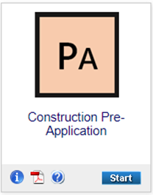

Figure 12 Construction Pre-Application Icon

# Filling Out and Submitting a Pre-Application Meeting Application

The Iowa DNR strongly encourages pre-application meetings in order to facilitate review and permitting of large and complex projects. When both parties have clear expectations, the permitting process tends to be smoother. The DNR cannot assure how quickly that projects submitted without this prior coordination can be reviewed or permitted.

A pre-application meeting for Prevention of Significant Deterioration (PSD) projects provides the Department an opportunity to review the draft application and provide guidance to the applicant of suggested changes and potential issues with the project. This allows the applicant an opportunity to update the application prior to submittal so a better final application can be submitted, which in turn reduces the number of information requests during the official review of the project.

The meeting is used to discuss with the Department the status of dispersion modeling, preconstruction monitoring, and BACT analysis. Also, to be discussed is whether this will be a phased project, communication strategies and expectations, and setting of a project schedule. At least two weeks before the meeting, an application that is at least “80 percent complete” and an agenda outlining the meeting is to be submitted to the Department for review.

## Pre-Application Options

Next, the Pre-Application Options screen will appear (see Figure 13). Select from the two radio buttons which type of pre-application you are submitting. The required attachments for your application will vary depending on the choices selected on this screen.

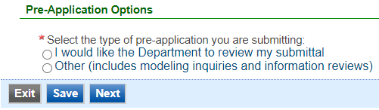

Figure 13 Pre-Application Options Example

If you select “I would like the Department to review my submittal”, the following options will appear (see Figure 14).

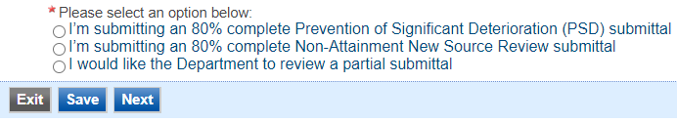

Figure 14 Department Review Example

Once you have completed all the required fields, please click on “Save” and then “Next”.

## Form CP

Next, the Form CP (Cover Page) screen will appear. Depending on the selection made previously on the Pre-Application Options screen, different selections will be available on this screen for your pre-application meeting request. If you selected “I would like the Department to review my submittal”, the following screen will appear in Figure 15.

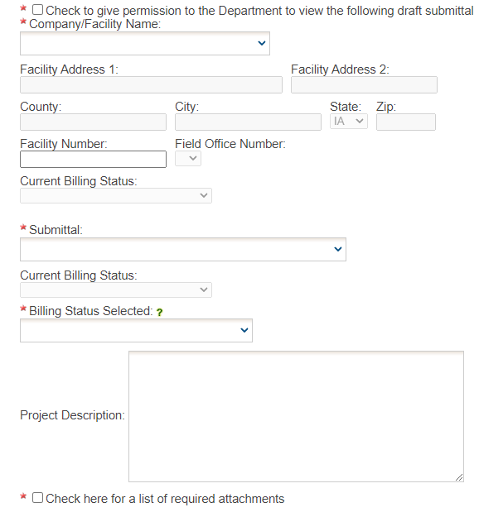

Figure 15 Form CP Screen

Please check the box at the top of this screen to give permission to the Department to view a draft submittal. Please click on the “Company/Facility Name:” dropdown menu and select the Company/Facility Name that the project should be associated to. The facility address, facility number, field office number, and current billing status will auto-fill. If the facility information is not correct, please contact [easyair@dnr.iowa.gov](mailto:easyair@dnr.iowa.gov) to change the facility information.

To select which draft submittal you would like the Department to review, please click on the “Submittal:” dropdown menu and select the submittal ID (five-digit code) for the appropriate application. The submittal ID for each pending submittal can be found by going to “Edit Pending Submittals” on the “Submittal” tab at the top-left area of the website. The current billing status for the selected submittal will be automatically filled from that application. The “Billing Status Selected:” field should be used to indicate the actual billing status for the facility, if the billing status is incorrect. If the “Current Billing Status” is correct, please select the same billing status under “Billing Status Selected”. If you have any questions about Air Quality Fees, please visit the DNR webpage [Air Quality Fees](https://www.iowadnr.gov/Environmental-Protection/Air-Quality/Air-Quality-Fees).

Please provide a brief project description in the “Project Description” text box. If you would prefer to attach your project description to the submittal, please enter “See attachments” in the text box and attach your description in the Attachments section.

At the bottom of this page will be a checkbox to list the required attachments for the submittal. Depending on your selection on the Pre-Application Options screen, there will be different required attachments.

* If you selected “80% complete Prevention of Significant Deterioration (PSD) submittal”, the required attachments will be:
  + Preliminary BACT determination
  + Preliminary soils and vegetation analysis
  + Modeling protocol and pre-construction monitoring analysis
* If you selected “80% complete Non-Attainment New Source Review submittal”, the required attachments will be:
  + Preliminary LAER determination
  + Preliminary emission offsets
  + Preliminary alternate site analysis
  + Compliance certification
* If you selected “partial submittal”, a list of required attachments is not listed. Please use the checkbox to indicate whether you are attaching documents to the submittal.

If you selected “Other (includes modeling inquiries and information reviews)” in the Pre-Application Options screen, the following screen will appear in Figure 16.

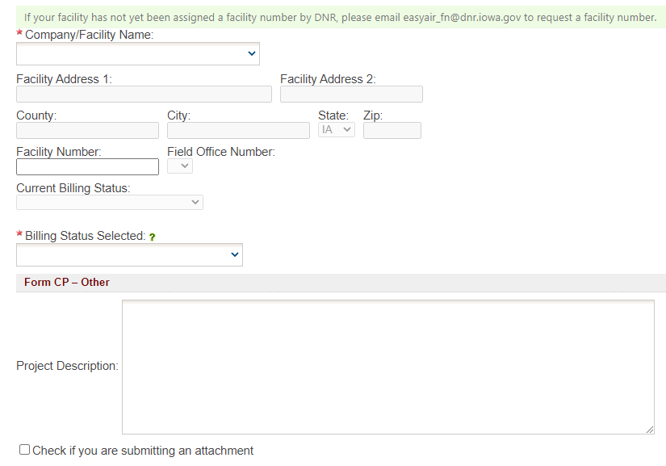

Figure 16 Form CP Screen

Please follow the instructions above for completing this form. Once you have completed all the required fields, please click on “Save” and then “Next”.

## Form AF

Next, the Form AF (Application Fee) screen will appear if the “Billing Status Selected” is “Major Source – Hourly Fee” (see Figure 17). This form is not required if the “Billing Status Selected” is “Minor Source – Fee Per Application”.

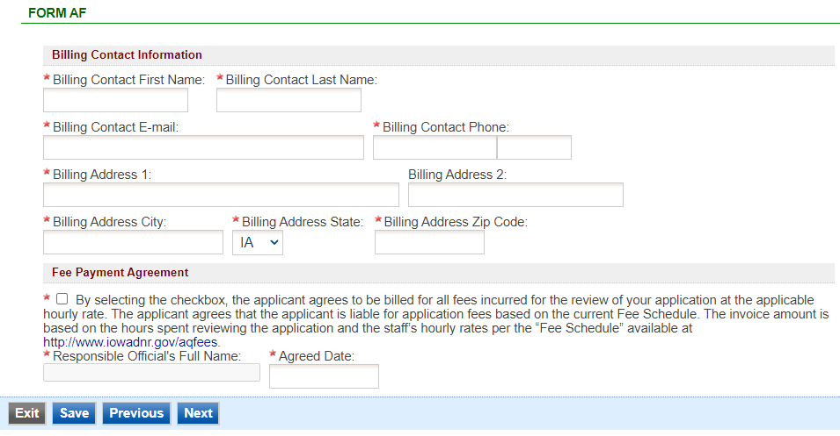

Figure 17 Form AF Screen

If this form is applicable, please enter the contact information for the person who should be contacted regarding billing for the review of the pre-application materials. Please review the fee payment agreement carefully and check the box indicating that you agree to be billed for all fees incurred for the review of your application at the hourly rate, then enter the Responsible Official’s Full Name and date. Once you have finished entering the information, click “Save” and then “Next”. If there is required information missing from the section, the Iowa EASY Air system will highlight the required fields in red. You may proceed with the application, but the system will not allow you to submit the application until all the required fields are completed during the Validation step.

## Attachments

Next, the Attachments screen will appear (see Figure 18). Depending on what was selected in the Pre-Application Options screen, the required attachments will appear based on Form CP. Please upload the required attachments to the application and any other attachments at this screen.

Attachments may be uploaded to the application electronically, or mailed/faxed to the Department.

The Iowa DNR recommends that attachments be submitted electronically so as to not slow down the application process.

Please attach any documents required to assist the assigned engineer with completing the project on this screen.

To include your attachment(s) in the Iowa EASY Air system, select the “Online” radio button and then click on the “Upload” button. Only one file may be uploaded at a time, and the maximum file size allowed is 100 MB. The example attachment screen shown below may appear differently depending on what was selected earlier in the application in the Pre-Application Options screen.

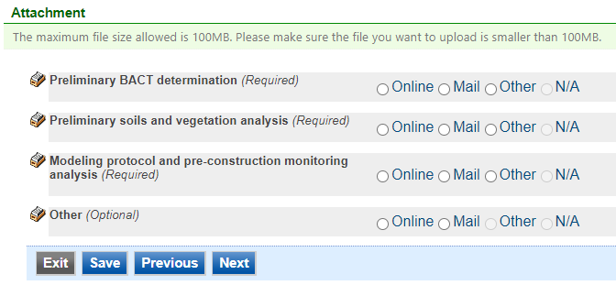

Figure 18 Attachment Screen

Select “Choose File” to select the document to be uploaded (see Figure 19). These file types are accepted by the system:

* pdf, doc, docx, txt, xls, xlsx, cvs
* jpeg, jpg, bmp, png, gif
* xml

You may include a comment for each attachment. When you have successfully selected the document, click on “Save” to upload the attachment.

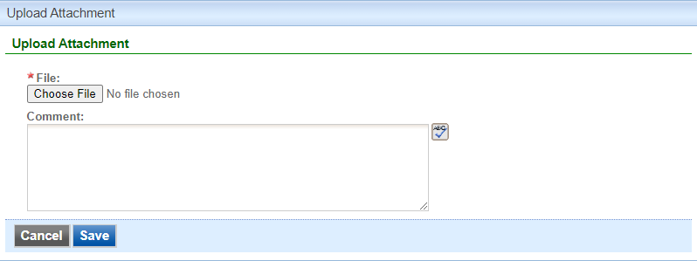

Figure 19 Attachment Screen

The uploaded attachment will display on the screen as shown in Figure 20. To remove an attachment, click the red “x” icon. The Iowa EASY Air system will confirm with you that you want to delete the record with a pop-up message. Select “Ok” on this message to confirm, or “Cancel” to stop the deletion request. To edit the attachment comment, click on the attachment comment, edit the comment, then select “Save” to update the comment or “Cancel” to cancel the change.

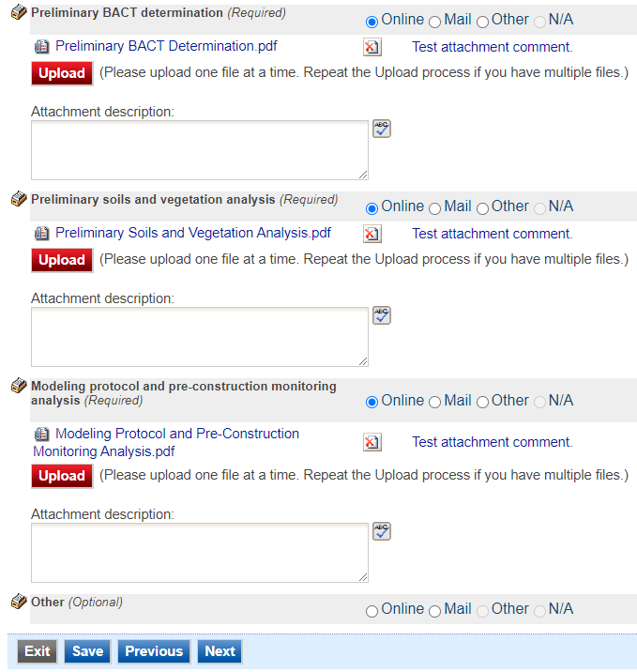

Figure 20 Example Attachment Screen

Please click “save” at the bottom of the screen to save the page.

If you do not click “save” before loading into another page, you will lose your current progress entering information.

If you plan to mail or fax the attachments, please select the “Mail” radio button on the attachment screen. If mailing attachments, include the attachment descriptions and submittal ID. Mail attachments to the following address:

Application Login Desk

Air Quality Bureau

502 E 9th Street

Des Moines, IA 50319

Please select “Other” if you wish to submit the document a different way, such as hand delivery, fax, or describe the reason in the comment text box. If faxing documents, include the attachment descriptions and submittal ID. The Air Quality Bureau fax number is (515) 725-9501.

## Validation

Next, the Validation screen will appear (see Figure 21). The system will check the application forms for required information that is missing, and will display a result similar to the figure below:

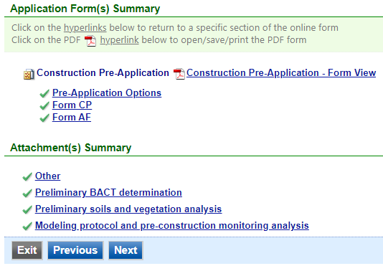

Figure 21 Example Validation Screen

If there are no noted issues, click the “Next” button. If there are issues, you may navigate to the section by selecting the section on this screen to complete the missing information.

Please note that the system will only check for missing information, and will not validate whether the information is complete or accurate.

## Submission

Next, the Certification of Submission screen will appear (see Figure 22). Please review the statement at the top of the screen, then check the box at the top of the screen, answer the security question, enter your pin, and click “Submit”.

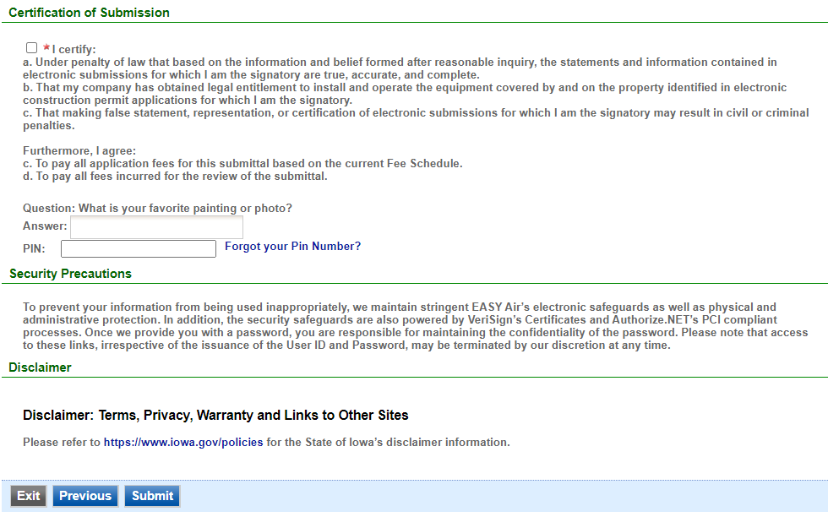

Figure 22 Example Certificate of Submission Screen

You will get a confirmation screen similar to the one shown below in Figure 23 and a confirmation email will be sent to you.

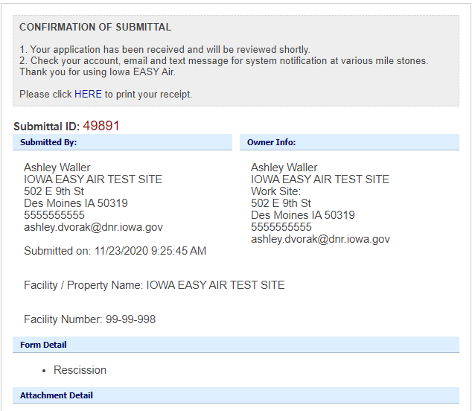

Figure 23 Confirmation of Submittal

**If you have questions, please call the Iowa EASY Air Helpdesk  
at (515) 725-9569 or (515) 204-3749.**

**Or, send an email to** [**easyair@dnr.iowa.gov**](mailto:easyair@dnr.iowa.gov)